Date: 09/08/2024
Roll No. and Name: 24ITC087 Khush Pithva
Course Code and Name: 2CS101 Computer Programming
Practical No: 3(a)
AIM: Write a program to take the values for A, B, C of a quadratic equation A∗ X2+B∗ X+C=0 and then find all the roots of the equation. It is guaranteed that A=!0 and that the equation has at least one real root.
Methodology followed:
#include<stdio.h>
#include<math.h>

int main()
{
float a,b,c,d,x1,x2;
printf("Enter the value of A : ");
scanf("%f",&a);
printf("\nEnter the value of B : ");
scanf("%f",&b);
printf("\nEnter the value of C : ");
scanf("%f",&c);
d=(b*b)-(4*a*c);
if(d<0){
printf("\nEquation has no real root");
}
else if(d==0)
{
printf("\nEquation has only one root");
x1=(-b)/(2*a);
x2=x1;
printf("\n root is %.2f",x1);
}
else
{
printf("\nEquation has two real root");
x1=((-b)+pow(d,0.5))/2*a;
x1=((-b)-pow(d,0.5))/2*a;
printf("\n first root is %.2f",x1);
printf("\n second root is %.2f",x2);
}
}

Output:
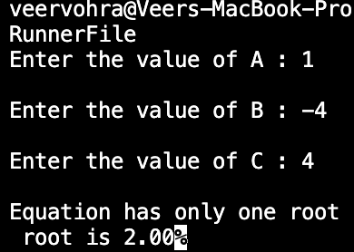

Practical No: 3(b)
AIM : In an organization, employees are paid on an hourly basis. Clerks are paid 100/hr, Teachers are paid 200/hr and the principal is paid 400/hr. If the weekly hours exceed 44, then employees should be paid 2 times their regular pay for the overtime. Write a C program to compute the weekly salary of the employee and also the program should take care that the employee should not be paid for hours beyond 50 in a week. Use the best suitable control construct to implement the program.
Methodology followed:
#include<stdio.h>
int main()
{
int workhour,salary;
char employee,c,p,t;
printf(" enter c for clerk, t for teacher,p for principal\n");
printf("Enter your choice : ");
scanf("%c",&employee);
printf(" enter the work hours : ");
scanf("%d",&workhour);
if (employee=='c'){
if (workhour<44){
salary = workhour*100;
}
else if(workhour>=50){
salary=44*100+6*200;
}
else if(workhour>44 && workhour<50);{
salary=44*100+(workhour-44)*200;
}
printf("Your salary is %d.\n",salary);
}
if(employee=='t'){
if (workhour<44){
salary = workhour*200;
}
else if(workhour>=50){
salary=44*200+6*400;
}
else if(workhour>44 && workhour<50){
salary=44*200+(workhour-44)*400;
}
printf("Your salary is %d.\n",salary);
}
if(employee=='p') {
if (workhour<44){
salary = workhour*400;
}
else if(workhour>=50){
salary=44*400+6*800;
}
else if(workhour>44 && workhour<50){
salary=44*400+(workhour-44)*800;}
printf("salary=%d",salary);
}
return 0;
}
Output :
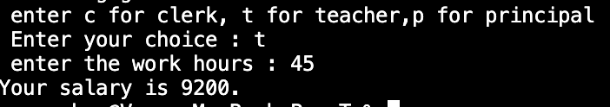

Practical No: 3(c)
AIM : Ajay and Amit are playing a game with a number X in one turn they can multiply X by 2 the goal of the game is to make X divisible by 10 write a C program to find the number of turns necessary to win the game.
Methodology followed:
#include <stdio.h>
int main()
{
int x;
printf("enter the value of x : ");
scanf("%d",&x);
if(x%10==0)
{
printf("\nyou win in zero turn");
}
else if(x%5==0){
printf("\nyou win in one turn");
}
else {
printf("\nit may be impossible");
}
return 0;
}
Output :
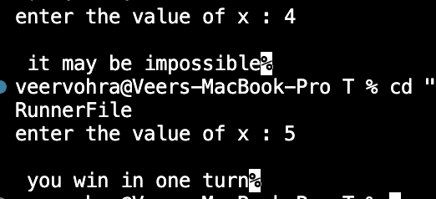
Practical No: 3(d)
AIM : Write a program to implement a simple number guessing game. Program should generate an integer randomly and ask the user to guess the integer. Based on the number guessed, it should display the appropriate message (correct or incorrect).
Methodology followed:

#include <stdio.h>
#include <stdlib.h>
#include <time.h>

int main() {
int secret_number, guess;
int min = 1, max = 100;

srand(time(NULL));

secret_number = rand() % (max - min + 1) ;

printf("Welcome to the Number Guessing Game!\n");
printf("I have chosen a number between %d and %d.\n", min, max);

do {
printf("Enter your guess: ");
scanf("%d", &guess);

if (guess < secret_number) {
printf("Too low! Try again.\n");
} else if (guess > secret_number) {
printf("Too high! Try again.\n");
} else {
printf("Congratulations! You've guessed the number correctly!\n");
}

} while (guess != secret_number);

return 0;
}
Output :
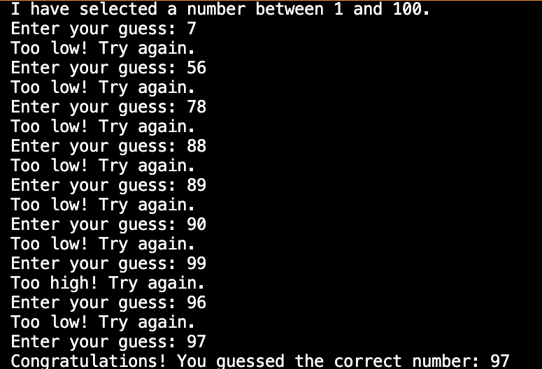

Practical No: 3(e)
AIM : Write a C program to find the grade of a student based on the following policy. Class test: 12% weightage, Tutorial-12%, SE:16%, LPW:20%, SEE:40%. Grade is decided based on the below range of total marks.
Methodology followed:
#include <stdio.h>

int main() {
float class_test, tutorial, se, lpw, see;
float total_marks;

printf("Enter marks for Class Test (out of 100): ");
scanf("%f", &class_test);

printf("Enter marks for Tutorial (out of 100): ");
scanf("%f", &tutorial);

printf("Enter marks for SE (out of 100): ");
scanf("%f", &se);

printf("Enter marks for LPW (out of 100): ");
scanf("%f", &lpw);

printf("Enter marks for SEE (out of 100): ");
scanf("%f", &see);

total_marks = (class_test * 0.12) + (tutorial * 0.12) + (se * 0.16) +
(lpw * 0.20) +
(see * 0.40);

const char* grade;

if (total_marks >= 91) {
grade = "A+";
} else if (total_marks >= 81) {
grade = "A";
} else if (total_marks >= 71) {
grade = "B+";
} else if (total_marks >= 61) {
grade = "B";
} else if (total_marks >= 51) {
grade = "C+";
} else if (total_marks >= 40) {
grade = "C";
} else {
grade = "Fail";
}

// Display the results after all conditions
printf("Total weighted marks: %.2f\n", total_marks);
printf("Grade: %s\n", grade);

return 0;
}
Output :
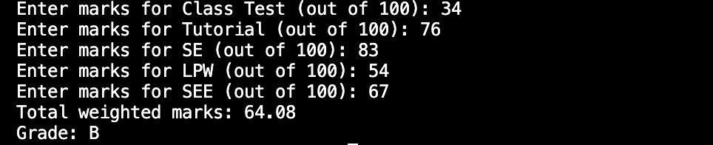

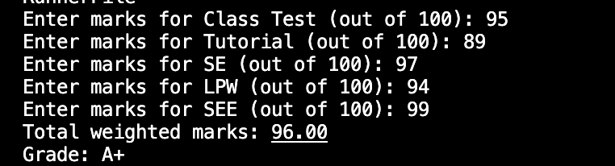

Theoretical Principle: Use of conditional statements like if else.

Conclusion: By above practicals I got the knowledge of conditional statements.

